**ENED 1091 Engineering Models II**

**Project Plan**

This project plan should be completed by the team and submitted by Nov 16th.

The team leader should submit the report to Blackboard. Only ONE submission per team!

**Description of Team:**

**Hayden Schiff (solo) – Computer Science**

List the members of your team (indicate team leader) and the majors of each team member.

**Preliminary Plan:**

1. Describe what concept you are planning to teach using a MATLAB GUI and why you have chosen to teach this particular concept.

My GUI will teach users about motion physics through the simulation of a car crash. I chose this concept because I feel pretty confident in my knowledge of the underlying math. I am also interested in learning about graphics programming – I hope to implement a rudimentary first-person view from the driver’s perspective.

1. Describe your plans for what the user will be required to do in order to use the GUI to learn your chosen concept. You should talk about what the user will need to do to interact with the GUI itself (enter values, select options from a drop down menu, etc.), what calculations or other actions the user will need to do outside of the GUI environment, and what prior knowledge you are expecting the user to already have.

The user is given a wide breadth of controls with which to manipulate the simulation. Using sliders or text inputs, they can adjust the many variables of the simulation such as velocity, acceleration, mass, timings, etc. Once they are satisfied with their configuration, they can start the simulation using the “go” button to watch it play out as an animation. They can control the progression of the simulation using the Time slider and the Stop button. After they’ve watched the simulation, they can re-adjust their variables, then re-run the simulation to see how their changes affect the outcome.

1. Paste a copy of your preliminary layout for your GUI in the space below.

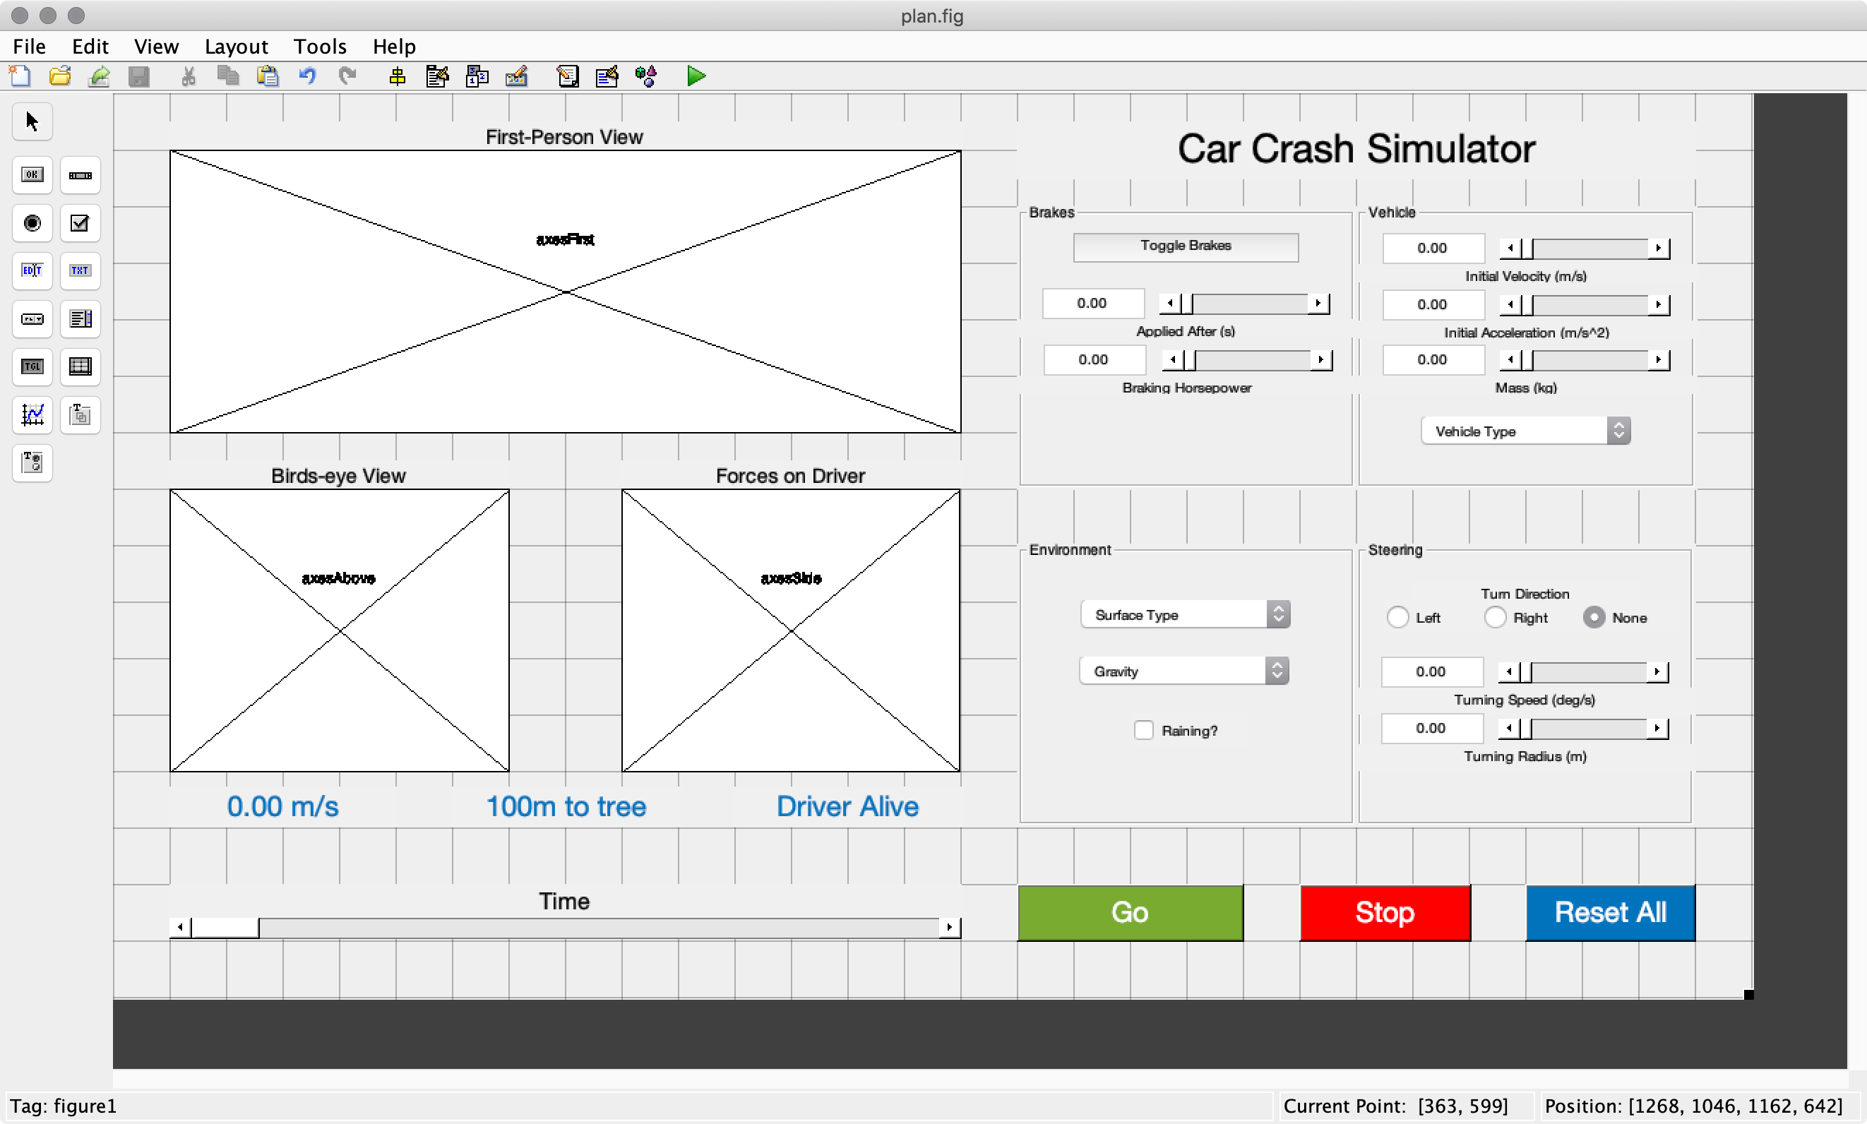

1. Describe your initial plan for splitting coding responsibilities among the team members.

I’m a solo team, so I’ll be doing everything myself.